1. Rapid Math
2. Math
3. The player is given 1 minute to answer as my questions as they can. Correct answers add .5 seconds to the clock, incorrect answers will remove 1.5 secsonds from the clock. The player is then presented with a random math problem which is randomly chosen from a pool of addition or multiplication problems. The addition problems are either single or double digits and the multiplications will be digits between 0 through 10. The player has as many chances to answer the question before the next question is presented. The game continues in this manner until the time runs out. At the end of the game, the player is given a score based on the amount of time remaining on the clock, and the number of questions answered correctly. The objective of the game is to answer as many questions correctly as possible and to keep the countdown clock running for as long as possible.

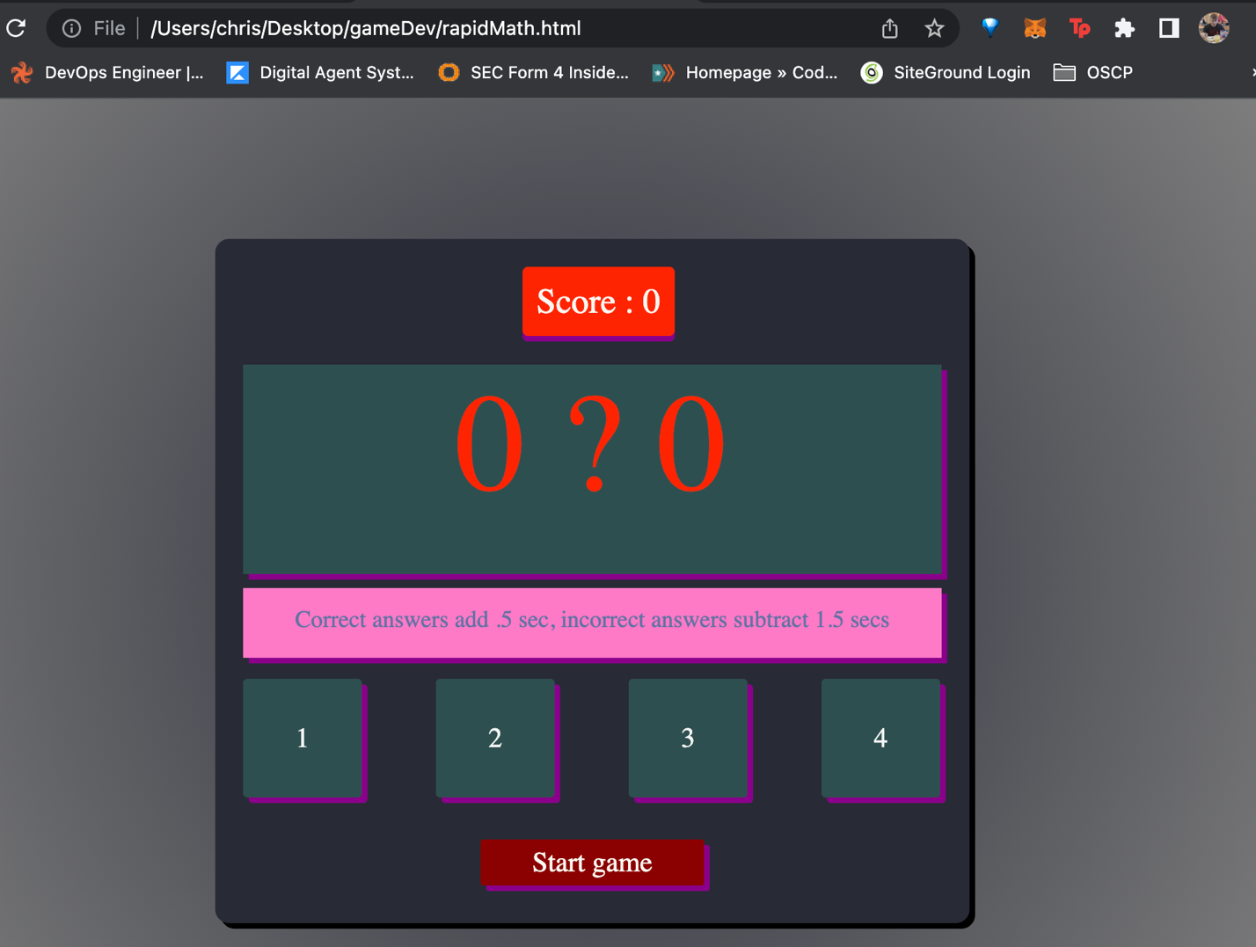

Written in html, css, and javascript